

Faculty of Applied Sciences  
Bachelor of Science in Computing

**COMP490 Final Year Project  
Weekly Status Report**Academic Year 2022/23

|  |  |
| --- | --- |
| Your project title | |
|  |  |
| Project number: | Your project number |
| Student ID: | Your student ID |
| Student Name: | Your name |
|  |  |
| Supervisor: | Your supervisor |
| Assessor: | Your assessor |

Table of Contents

1 Preliminary Project Work Plan 2

2 First semester W4-W14 3

2.1 Week 4 3

2.2 Week 5 3

2.3 Week 6 4

2.4 Gantt Chart 5

2.5 Week 7 6

2.6 Week 8 (repeat up to Week 14) 6

3 Second semester W1-W13 8

3.1 Week 1 8

3.2 Week 2 (repeat up to Week 12) 8

3.3 Week 13 (Conclusion) 9

# Preliminary Project Work Plan

In this section, attach your preliminary project work plan as submitted in the Project Proposal in Week 3. Progress in Week 4 – Week 6 is checked against this work plan.

[ Include project work plan below]

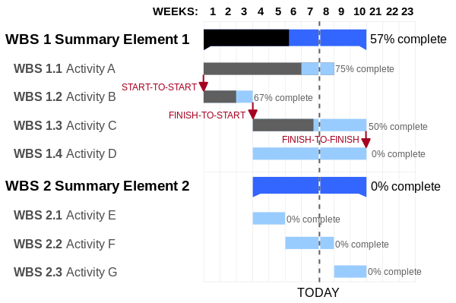

# First semester W4-W14

Starting from Week 4 of the first semester, you have to submit weekly updates on your progress in a Weekly Status Report. You have to briefly report what tasks you have accomplished and your plan for the coming weeks in the report. This helps your supervisor to monitor your progress.

Open a section for each week. Follow the definition of week number in the FYP calendar in O:\FYP.

## Week 4

Report Date: dd/mm/yyyy

### Tasks done this week

List what tasks you’ve accomplished in this week.

### Plan for next week

List the tasks you plan to do in the next week. In case you’re behind schedule, describe what you will do to catch up.

## Week 5

Report Date: dd/mm/yyyy

### Tasks done this week

List what tasks you’ve accomplished in this week.

### Plan for next week

List the tasks you plan to do in the next week. In case you’re behind schedule, describe what you will do to catch up.

## Week 6

Report Date: dd/mm/yyyy

### Tasks done this week

List what tasks you’ve accomplished in this week.

### Plan for next week

List the tasks you plan to do in the next week. In case you’re behind schedule, describe what you will do to catch up.

## Gantt Chart

This section shows the first version of the Gantt chart, as submitted in Week 6. It includes detail schedule for the project. The Gantt chart sets up the overall schedule for the whole project. Therefore, from Week 7 of the first semester onwards, you also need to check your progress against the Gantt chart.

You may revise the schedule in the Gantt chart during the course of the project. This is necessary, for example, in case of risk mitigation. You must include the updated Gantt chart in the Weekly Status Report in a section like this one. Explain the reasons for schedule revision. You should also adopt a sound method of version control to avoid potential confusion regarding which version is currently being used.

Modified Date: dd/mm/yyyy

Include Gantt Chart below



## Week 7

Report Date: dd/mm/yyyy

### Tasks done this week

List what tasks you’ve accomplished in this week.

### Progress check against Gantt chart

Use the Gantt chart to evaluate your progress.



### Plan for next week

List the tasks you plan to do in the next week. In case you’re behind schedule, describe what you will do to catch up.

## Week 8 (repeat up to Week 14)

Report Date: dd/mm/yyyy

### Tasks done this week

List what tasks you’ve accomplished in this week.

### Progress check against Gantt chart

Use the Gantt chart to evaluate your progress.



### Plan for next week

List the tasks you plan to do in the next week. In case you’re behind schedule, describe what you will do to catch up.

# Second semester W1-W13

## Week 1

Report Date: dd/mm/yyyy

### Tasks done this week

List what tasks you’ve accomplished in this week.

### Progress check against Gantt chart

Use the Gantt chart to evaluate your progress.



### Plan for next week

List the tasks you plan to do in the next week. In case you’re behind schedule, describe what you will do to catch up.

## Week 2 (repeat up to Week 12)

Report Date: dd/mm/yyyy

### Tasks done this week

List what tasks you’ve accomplished in this week.

### Progress check against Gantt chart

Use the Gantt chart to evaluate your progress.



### Plan for next week

List the tasks you plan to do in the next week. In case you’re behind schedule, describe what you will do to catch up.

## Week 13 (Conclusion)

Report Date: dd/mm/yyyy

### Tasks done this week

List what tasks you’ve accomplished in this week.

### Progress check against Gantt chart

Use the Gantt chart to evaluate your progress.

